**PYTHON ASSIGNMENT**

**INHERITANCE**

**COURSE CODE: MDS171**

**COURSE TITLE: PROGRAMMING USING PYTHON**

**SUBMITTED TO:** DR. J. Jayapriya,

Department of computer Science,

Christ University,

Yeshwanthpur Campus,

Bangalore – 560073

**SUBMITTED BY:** Angeline A (2348409),

1MDS – ‘B’,

Christ University,

Yeshwantpur Campus,

Bangalore – 560073

**SUBMITTED ON:** 10/09/2023

**SINGLE INHERITANCE**

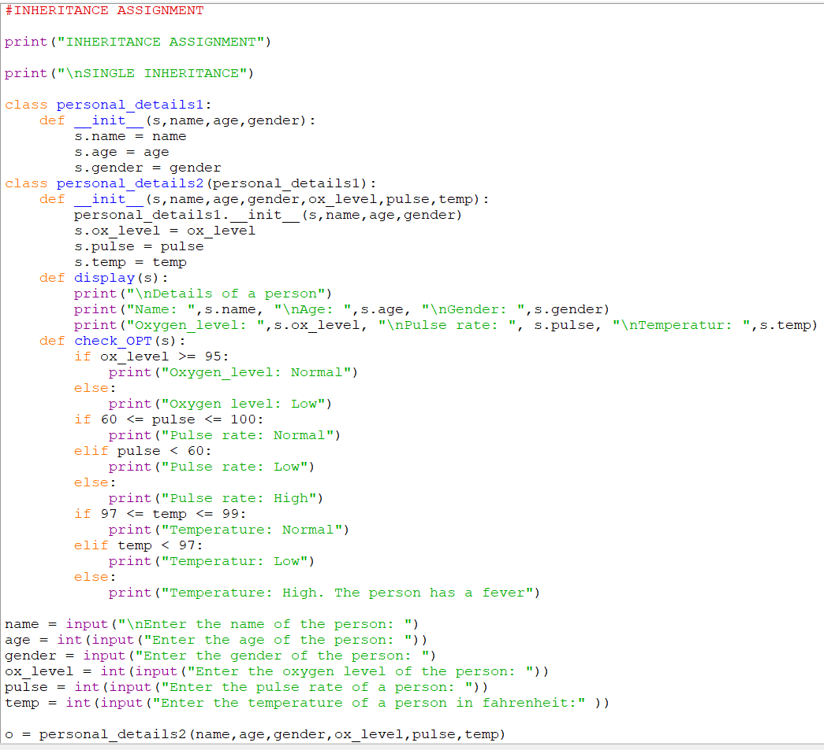



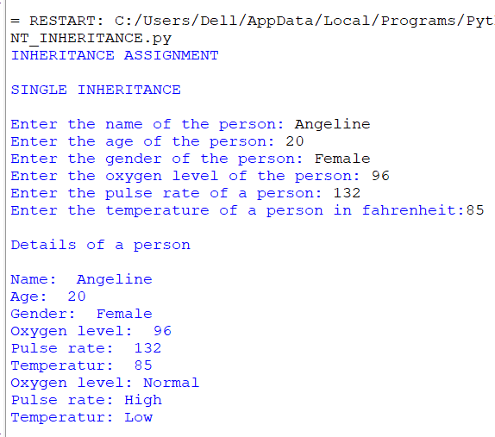

**MULTIPLE INHERITANCE**

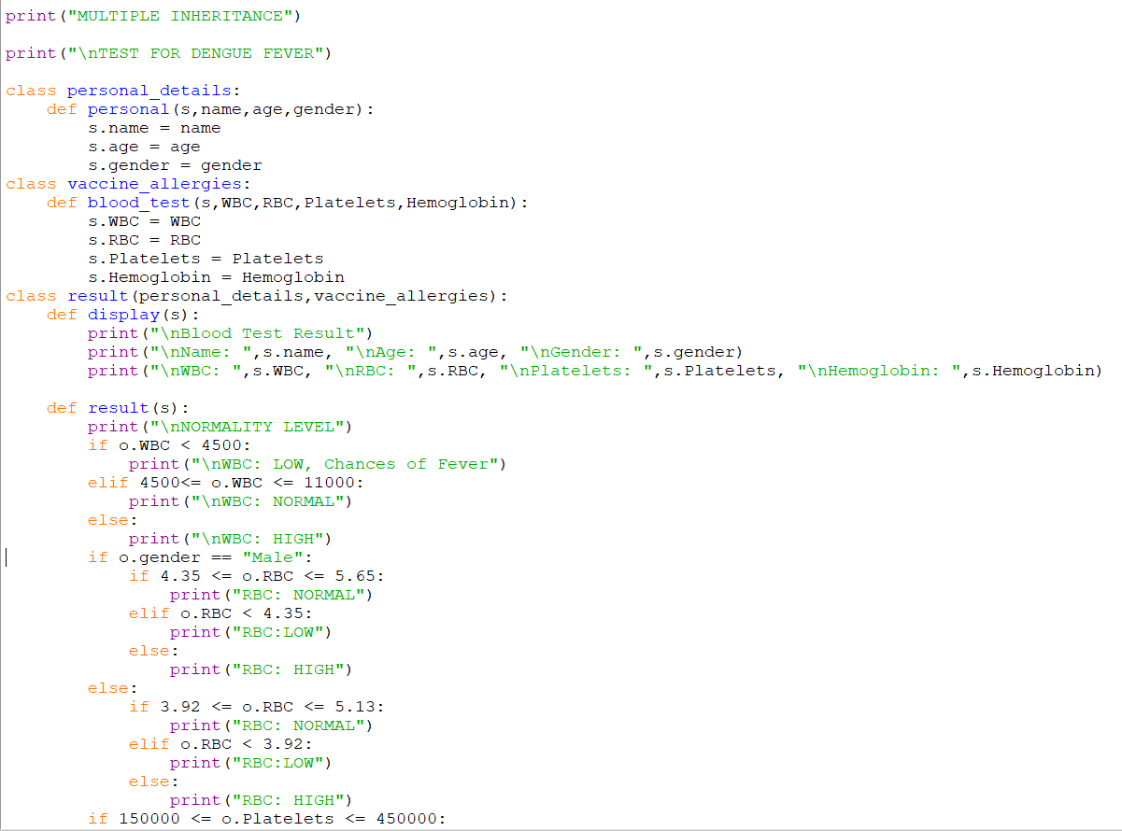

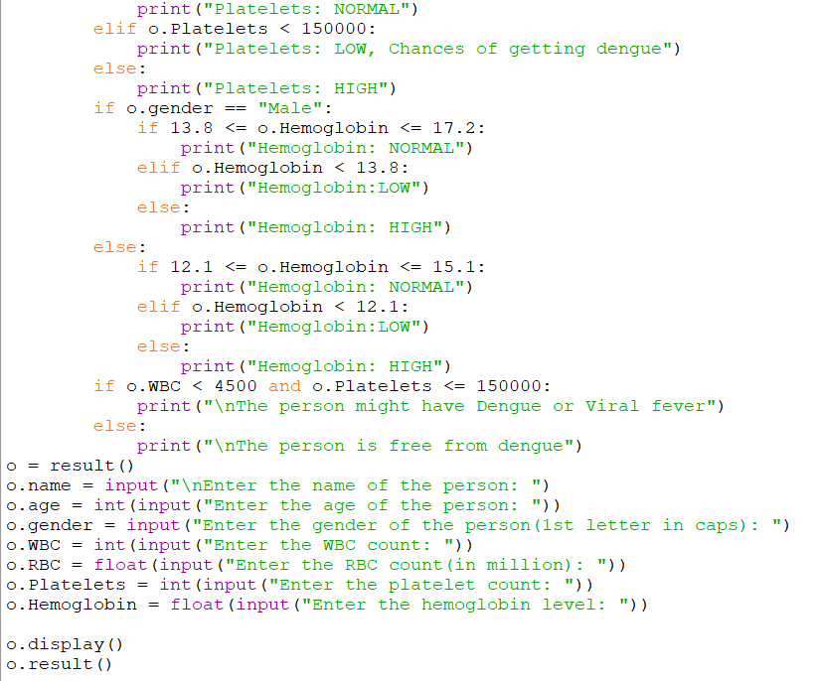

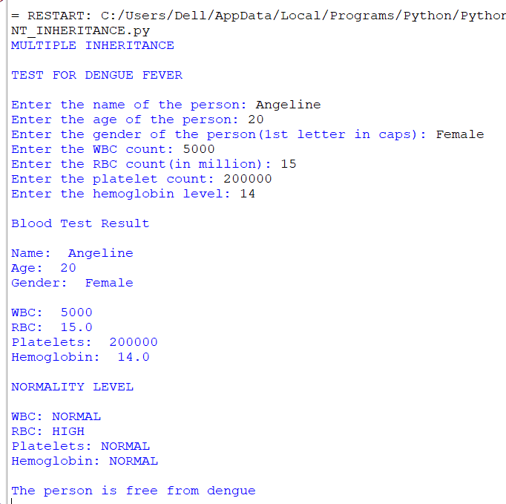

**MULTILEVEL INHERITANCE**

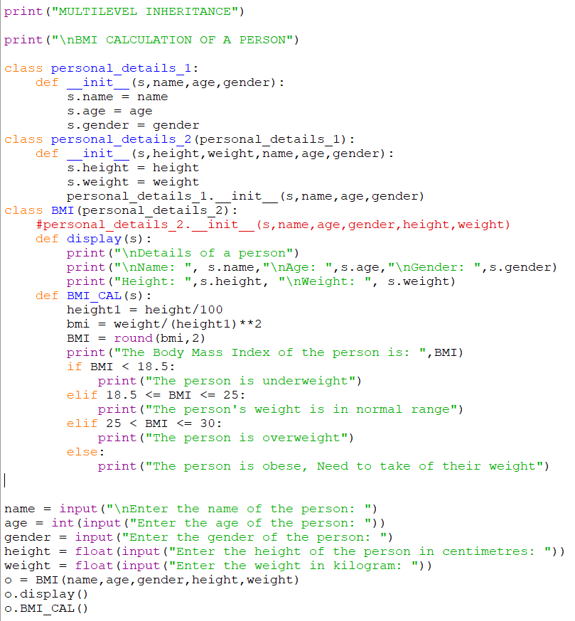

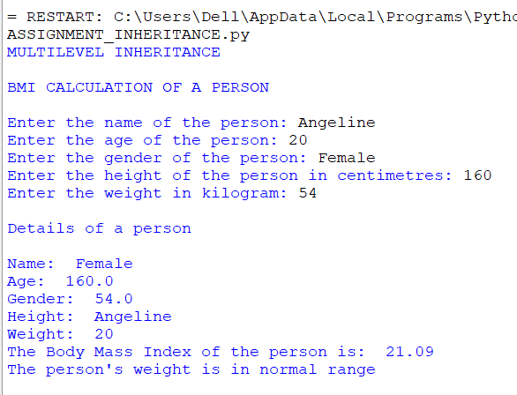

**HIERARCHICAL INHERITANCE**

